Email_engage_aggr

Runs bteq :/infosrvr/app/edw/source/email_engage_aggr/bteq/email_engage_aggr_crt_prev_mn.bteq

Runs datastage job : email_engage_aggr_rule_ref_tgt_p1_optimized

Runs datastage job : email_engage_aggr_measure_ins_stg_p1_optimized

Runs datastage job : email_engage_aggr_rule_ref_tgt_p1_optimized

Runs datastage job : email_engage_aggr_default_ins_tgt_p1_optimized

Runs datastage job : email_engage_aggr_compare_prev_app_tgt_p1_optimized

Runs datastage job : email_engage_aggr_stats_append_tgt_p1

1. Runs bteq :

/infosrvr/app/edw/source/email_engage_aggr/bteq/email_engage_aggr_crt_prev_mn.bteq

This script is executed at the beginning of the monthly process to checks the max(d_timestamp) of the previous month table and refresh data with the existing current month for comparison later on.

LOCK ${EDW_OS_PROCDB}.email_engage_prev_mn_proc FOR ACCESS

SELECT *

FROM

(

SELECT MAX(d_timestamp) AS d_prev_mn_dt

FROM ${EDW_OS_PROCDB}.email_engage_prev_mn_proc

) eep

WHERE EXTRACT(MONTH FROM eep.d_prev_mn_dt) = EXTRACT(MONTH FROM CAST('${EDW_ORDER_DATE}' AS DATE FORMAT 'YYYYMMDD') )

AND EXTRACT(YEAR FROM eep.d_prev_mn_dt) = EXTRACT(YEAR FROM CAST('${EDW_ORDER_DATE}' AS DATE FORMAT 'YYYYMMDD') )

;

.IF ERRORCODE <> 0 THEN EXIT ERRORCODE;

.IF ACTIVITYCOUNT = 0 THEN .GOTO OK_PROCEED ;

.LABEL ALREADY_RAN

.REMARK "=== The month of MAX d_timestamp in the previous month table is the same as current_month.";

.REMARK "=== The monthly process has already run for this month. ===";

.QUIT 8;

.LABEL OK_PROCEED

.REMARK "=== Delete the previous month table and insert the previous month data for comparison.";

LOCK ${EDW_OS_PROCDB}.email_engage_cur_mn_proc FOR ACCESS

DELETE

FROM ${EDW_OS_PROCDB}.email_engage_prev_mn_proc;

INSERT INTO ${EDW_OS_PROCDB}.email_engage_prev_mn_proc

SELECT *

FROM ${EDW_OS_PROCDB}.email_engage_cur_mn_proc ;

1. Runs datastage job : email_engage_aggr_rule_ref_tgt_p1_optimized

This job queries the aggregated staging table from the previous step left join on edw_main.email_engage_rule, only keep the rule that passed all criteria , join to edw_main.email_engage_code_by_rule to get c_email_engagement_cd for the rule, and determine the level of email engagement for the guest (keep the highest).

Runs query :



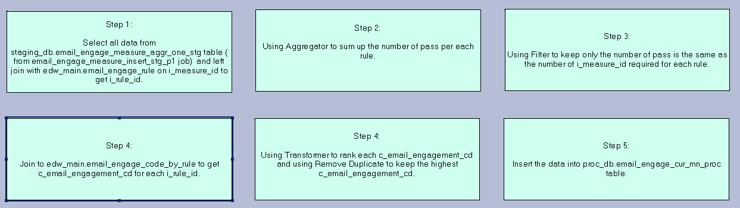

1. Runs datastage job : email_engage_aggr_measure_ins_stg_p1_optimized

This job queries edw_main.et_event_hist with the minimum report period from the previous step cross reference to gst_cons_xref , aggregate data based on edw_main.email_engage_measure and determine passed or failed for each measurement.

Run Query : 

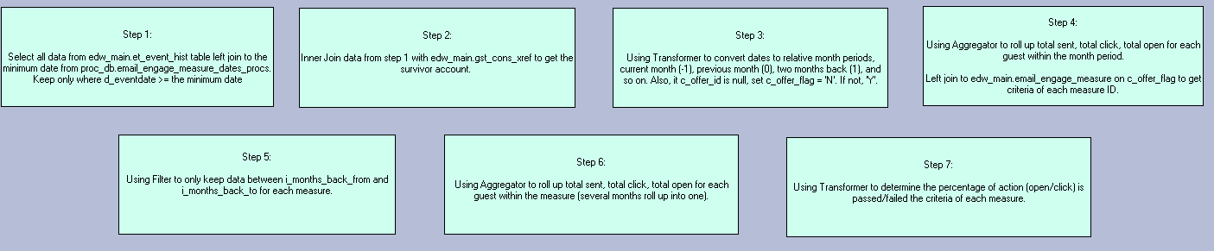

1. Runs datastage job : email_engage_aggr_rule_ref_tgt_p1_optimized

This job queries the aggregated staging table from the previous step left join on edw_main.email_engage_rule, only keep the rule that passed all criteria , join to edw_main.email_engage_code_by_rule to get c_email_engagement_cd for the rule, and determine the level of email engagement for the guest (keep the highest).

Runs Query :

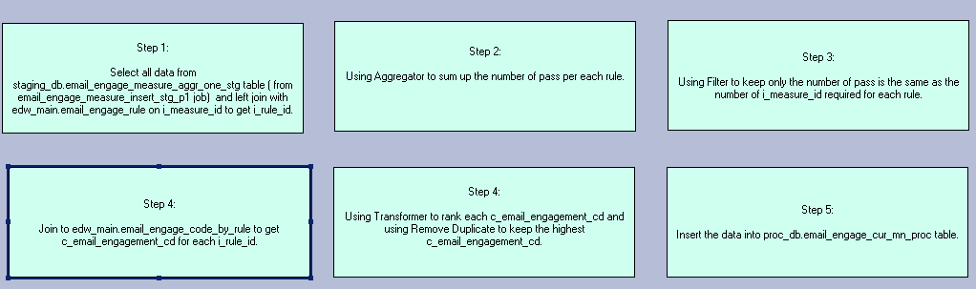

1. Runs datastage job : email_engage_aggr_default_ins_tgt_p1_optimized

This job identifies any guest with email but is not in the monthly email engagement aggregation table. Using c_job_cd = 'MN_PROC_DEFAULT' to get the c_email_engagement_cd. There can be only one measure for this default rule.

Runs Query :

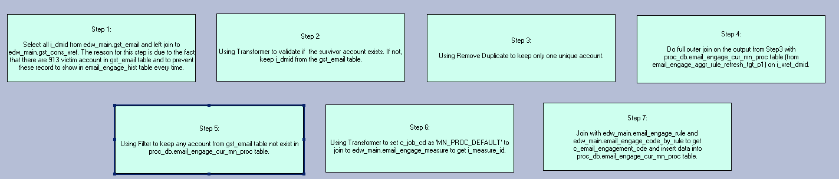

1. Runs datastage job : email_engage_aggr_compare_prev_app_tgt_p1_optimized

This job is to compare c_email_engagement_cd of a guest from the current with previous month. Insert the difference or not found into edw_main.email_engage_hist table.

Runs Query :

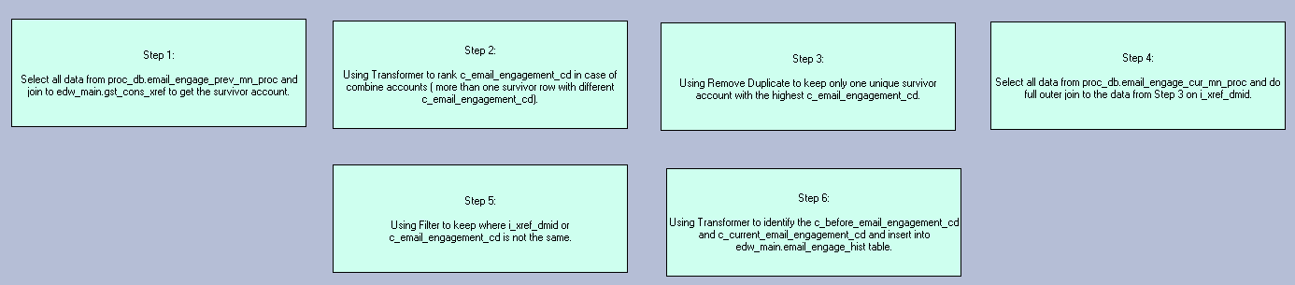

1. Runs datastage job : email_engage_aggr_stats_append_tgt_p1

This process will generate the count of each c_email_engagement_cd of the monthly tables and append the data into edw_main.email_engagement_stat with c_change_cd as 'M'.

Two tasks perform beblow queries :

INSERT INTO #PS_DB_Name.$EDW_OS_EDWDB#.email_engage_stats

( i_ins_run_id , c_email_engagement_cd, i_member_cnt , c_process_cd)

VALUES( #PS_STREAM_INFO.EDW_JOB_RUN_ID# , ORCHESTRATE.c_email_engagement_cd , ORCHESTRATE.i_member_cnt , 'M');

LOCKING #PS_DB_Name.$EDW_OS_PROCDB#.email_engage_cur_mn_proc FOR ACCESS

select c_email_engagement_cd, CAST(count(*) AS INTEGER) i_member_cnt from #PS_DB_Name.$EDW_OS_PROCDB#.email_engage_cur_mn_proc

group by c_email_engagement_cd;